1a.

This is an AR(1) model where the stationary condition () is not met as . Therefore it is not covariance stationary.

1b.

This is an ARMA(1,1) model where . This model is covariance stationary if

In this case so this model is covariance stationary.

1c.

The first axiom of if something is covariance stationary is that E() is constant however in this case E() = and is therefore time dependant and not constant. Thus it is not covariance stationary.

2.

is an AR(1) model and the stationary condition is met, therefore it is covariance stationary.

The expected value is calculated as follows.

E() = E() + = =

We can see that this pattern will repeat infinitely and therefore,

E() = = =

Thus statement B is the only true statement.

3a.

The conditional mean of is the mean of given its previous terms. The previous terms are irrelevant however as E( ) = and thus the conditional mean, E( ) = 0.

3b.

4a.

To find the existence of a unit root we can use the Dicky Fuller test. When looking at an AR(1)

A unit root is present if

Using this test we can put and in the form of an AR(1) and look at the value.

=

By substitution we get that

Thus so has a unit root.

By substitution we get that

Thus so has a unit root.

4b.

Cointegration is the process of looking at a combination of non-stationary variables to see if it yields something stationary, this must be linear combination.

For and we can see that which is covariance stationary so the cointegrating factors are 1 and -2.

For and we can see that which is also covariance stationary with cointegrating factors of 1 and -2.

4c.

5a.

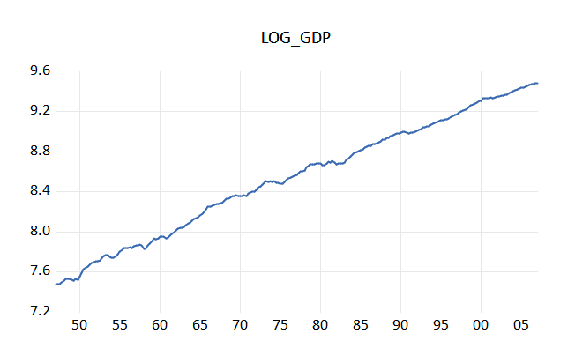

5b.

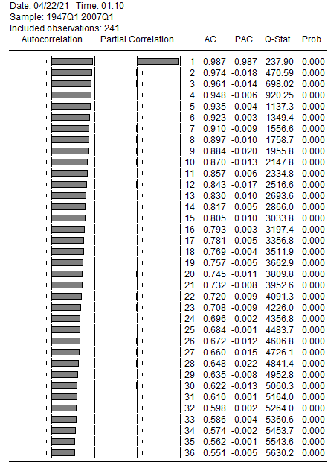

It is an AR(1) model where

5c.

We can follow the 7 step Box-Jenkins process to estimate and forecast the “best: ARMA model(s)

STEP 1 – Apply data transformation if necessary. Test for stationarity/nonstationary. If the series is nonstationary, transform the data to achieve stationarity.

As shown by part a, log(gdp) is nonstationary so we may apply the transformation of the 1st difference.

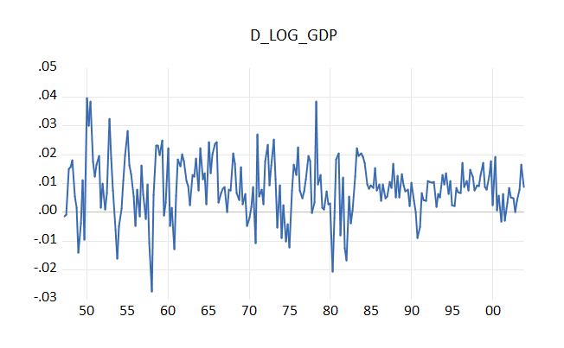

This initially appears to be stationary so we can test it using ADF and KPSS

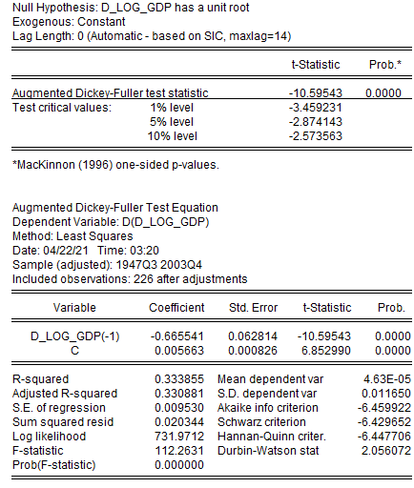

ADF shows us that it is stationary as the absolute value of the test-statistic is greater than the absolute value of the critical value at a 5% level, therefore we reject the null hypothesis of it being non-stationary.

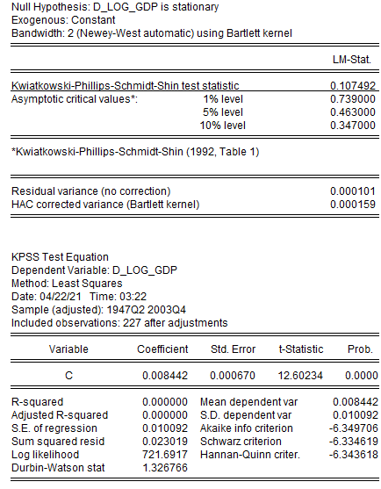

KPSS also shows us that it is stationary as the absolute value of the LM-Statistic is less than the absolute value of the critical value at a 5% level, therefore we accept the null hypothesis that it is stationary.

STEP 2 – Determine possible lag orders p and q in the ARMA(p,q) using (PACF/ACF)

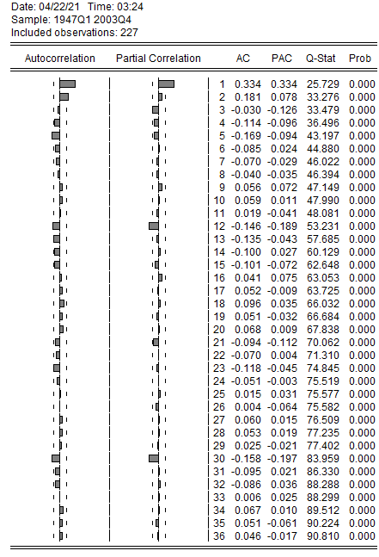

From this we can drive values for p using Partial Correlation and q using Autocorrelation. Looking at the patterns in the ACF and PACF a model of ARMA(p,q) seems most suitable as all other models do not fit the shape of the functions.

STEP 3 – Estimate the tentative models identified in step 2

Using this model P = (0,1) and Q = (0,1,2) leading to 5 possible combinations shown in step 4

STEP 4 – Compare and estimate models using an information criterion.

My two information criterions being used is AIC and SBC, below is the table showing the possible models with the lower score being better.

|  |  |  |
| --- | --- | --- |
| ARMA(p,q) | AIC | SBC |
| ARMA(0,1) | -6.423458 | -6.378195 |
| ARMA(0,2) | -6.376201 | -6.330937 |
| ARMA(1,0) | -6.450735 | **-6.405471** |
| ARMA(1,1) | -6.445264 | -6.384913 |
| ARMA(1,2) | **-6.458009** | -6.397658 |

Thus we have identified two possible models, AR(1) and ARMA(1,2)

STEP 5 – Test for autocorrelation in the error terms

As both models have p values of one we can use Durbin-Watson test. This test tell us that there is no autocorrelation when the statistic is close to 2.

For the AR(1) model we can use the Durbin-Watson statistic to test for autocorrelation. The DW statistics is 2.047677 which implies that there is no autocorrelation.

For the ARMA(1,2) we can also use the Durbin-Watson statistic to test for autocorrelation. The DW statistics is 1.975754 which implies that there is no autocorrelation.

STEP 6 – Test for heteroscedasticity (Testing for ARCH effects)

For AR(1):

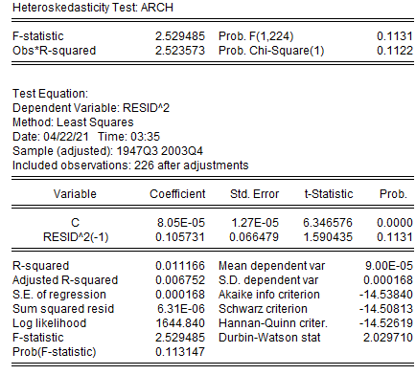

We do not reject the null hypothesis as Prob.F and Prob.Chi-Square are greater than 5% and thus there is no conditional heteroscedasticity.

For ARMA(1,2)

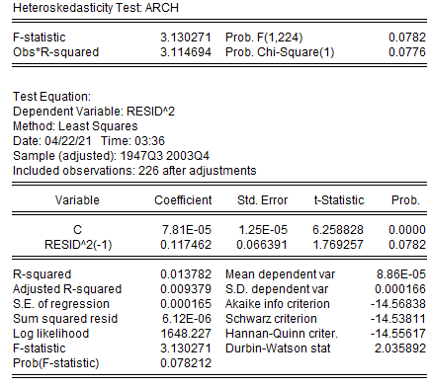

We do not reject the null hypothesis as Prob.F and Prob.Chi-Square are greater than 5% and thus there is no conditional heteroscedasticity.

STEP 7 – Test for normality (Jarque – Bera test)

To test normality we can use the Jarque-Bera test statistic and check is the P-Value is less than 5%

For AR(1)

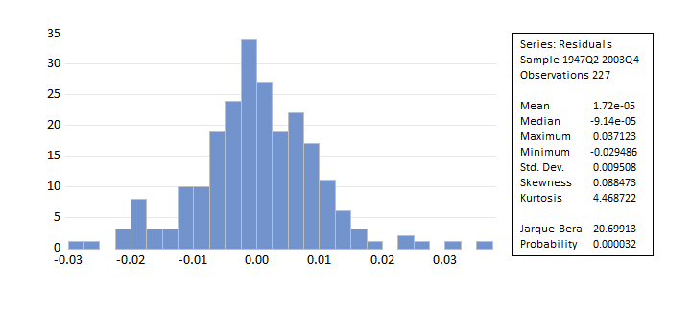

As shown by the distribution and P-Value below 5%, the errors are normally distributed.

For ARMA(1,2)

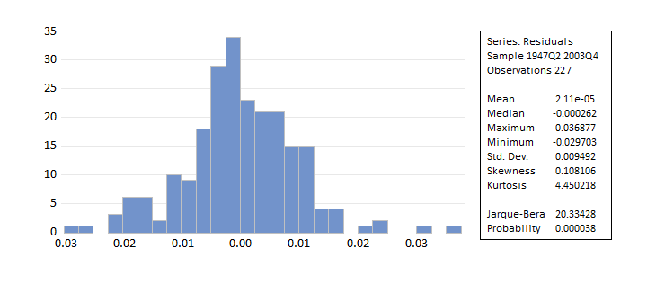

This model also has its errors normally distributed as the P-Value is below 5%.

FORCASTING

AR(1)

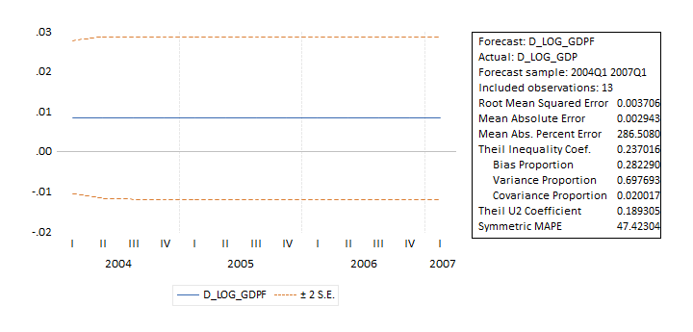

ARMA(1,2)

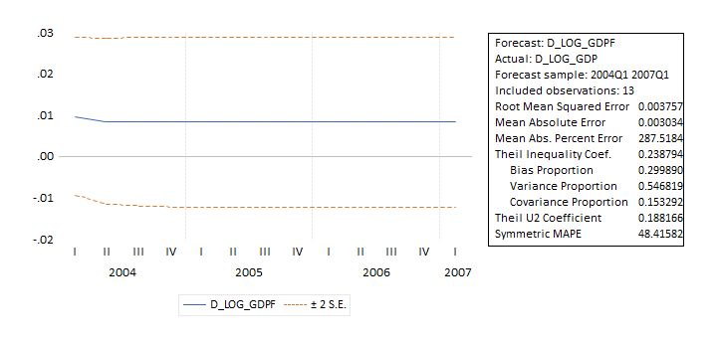

Both the AR(1) and ARMA(1,2) have very low MSE and MAE therefore we can conclude that they fit the data to a sufficient extent and is therefore a good model. However AR(1) appears to be slightly more accurate and therefore is the “best” ARMA model.

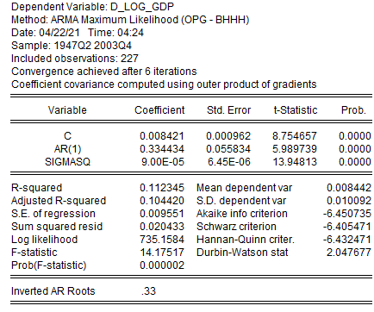

This is a summary of the model and therefore we can calculate the growth from the first difference.

Growth = = 0.40879. Therefore, the growth per quarter is 0.40879

6a.

6b.

6c.